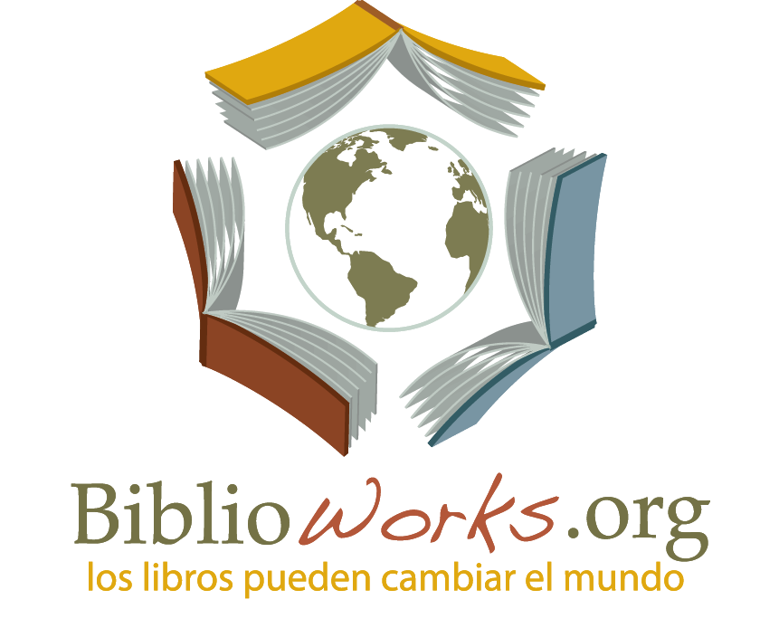

Biblioworks
Calle Junín #948
Sucre, Bolivia
Phone: +591 4 6440057
volunteer@biblioworks.org
www.biblioworks.org
Volunteer Application

Requested Personal Information

Date: Date of Birth:
First Name: Middle Name: Last Name:
Country of Origin: Primary Phone #: Email:
Emergency contact (name, relationship, phone #, address)
Date of Arrival to Sucre: How long do you want to volunteer?
How did you hear about BiblioWorks?
BiblioWorks website
Volunteersouthamerica.net
Idealist.org
A previous volunteer, name:
Other, please describe:

What volunteer position are you most interested in?
All positions require a minimum 5-week commitment unless otherwise noted.
Do you wish to live in a rural community? Yes No

Book Club Coordinator
English Teacher Have you taught English before? Yes No
Women’s Literacy Facilitator
Volunteer Coordinator and Communications Director (in the office in Sucre, minimum 6 month commitment)

Please briefly explain why you are interested in this project.

What do you intend to get out of this volunteer experience?

Here at Biblioworks we are dedicated to sustainable projects. Please explain how will you help keep this project sustainable. (How will you make sure future volunteers can continue this project?)

Skills, Background & Interests

Do you speak Spanish? Basic Intermediate Advanced Native Language No

Have you received any special education/training/certifications? If so, what kind? If a college graduate, please list your degree(s)/major(s).

List any of your technical/academic/job skills or interests that are relevant to your volunteer goals:

Date Signature

